FRIENDS AND FAMILY TEST
Results for February 2024

Thank you to all the patients who completed a friends and family test survey
in February 2024

- How likely are you to recommend our practice to family and friends if they needed similar care or treatment?
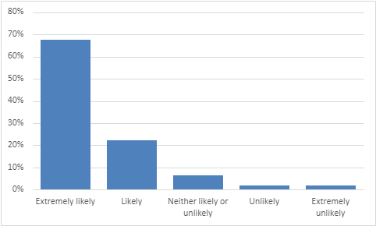

67% are extremely likely to recommend the practice.
22% are likely to recommend the practice.
6% are neither likely nor unlikely to recommend the practice.
6% are unlikely to recommend the practice.
2% are extremely unlikely to recommend the practice.

- If we could change one thing about your care or treatment, what would it be?
- Nothing, I have received excellent care.
- You could not improve on perfect.
- I’m totally satisfied with my care. I always have good care regardless of who I see.
- Doctor Rawson, a true gentleman.
- Telephone appointment with Tracey was absolutely great. She took time to explain what we were doing and what happens next.
- Do not change anything. We are fortunate to have an amazing surgery.
- Nothing, treatment first class.
- Everything is always good. Very helpful and friendly staff.
- Wait times too long for appointments and appointment time slots too short.
- Wait times too long for blood tests.
- Have easier access to see the doctor face to face. More appointment slots.
- To see a doctor when I need to. To be able to see the same doctor.
- Discuss reasons for treatment with the patient before changing medication.
- Better communication after tests.
- More, friendlier receptionists.
- To be listened to.
- Lock the door when being examined.
- The new booking system – definitely not straightforward. I just don’t understand it and can’t do it.
- Ditch the app and triage system. Get back to being truly approachable.
- Prefer to phone for an appointment without the paperwork.
- To be able to discuss more than one thing in an appointment.

